Examples of accessibility equipment

The following are a selection of items which can help to create a more inclusive experience for visitors with accessibility requirements at different venue types. Whilst not an exhaustive list, they are the type of items which may be fully or partially funded as part of any small grant scheme.

Each of the products in the list is hyperlinked to an example of that equipment type and has an image for illustration purposes, along with a description. The prices provided are a guide only.

The list is kindly provided by Access & Inclusion UK.

Please note that these suggested items are an example of the type of equipment that can be purchased to make your premises or operations more accessible with the support of the Culture, Leisure and Tourism Fund and we suggest doing your own research to determine best product or supplier for your business. We do not endorse the suppliers referred to in the web links, they are provided for example purposes only. The equipment needs to be fixed or used within specific tourism operation premises. We will look more favourably on bids where the equipment is sourced from an East Devon supplier.

Items to assist visitors who are Deaf or have hearing loss

Item | Image | Description / Purpose | Price
Portable hearing loop | 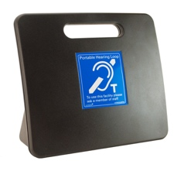 | Amplifies sound for visitors with hearing loss who use a particular type of hearing aid | £147.60 inc VAT for the portable induction desk loop system shown
Tour Guide Hearing loop | 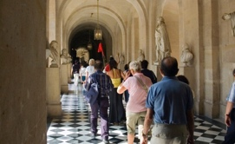 | As above, and can be used for multiple visitors on guided tours | Varies according to manufacturer and number of receivers. A recent quote from KTPUK for a tour guide hearing loops and 4 receivers was £1,995
Deaf Guard Device | 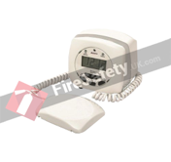 | Vibrates, flashes and displays the word ‘Fire’ when it detects a fire alarm, improving safety for visitors who are Deaf or have hearing loss | £184.79 inc VAT
Flashing door chime | 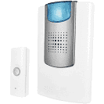 | Portable door chime which flashes when activated to assist visitors who are Deaf or have hearing loss | £19.20
Vibrating and Flashing alarm clock | 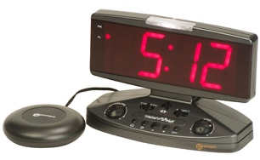 | Wakes visitors with an adjustable audible alarm or a vibrating pad under the pillow.  Support visitors who are Deaf of have hearing loss | £47.99

Items to assist visitors who are Deaf or having hearing loss or who are blind or partially sighted

Item | Image | Description / Purpose | Price
Large buttoned telephone with amplifier | 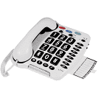 | Large buttons to assist visitors with sight loss and amplifier to increase the sound level on incoming calls through the ear piece | £84.00

Items to assist visitors who Blind or partially sighted

Item | Image | Description / Purpose | Price
Sheet Magnifiers | 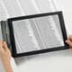 | Magnifies text and other details for a more inclusive visitor experience for partially sighted visitors. | £7.99 inc VAT
Bright Reading Lamp | 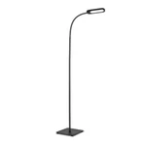 | Provides adiditional illumination for partially sighted visitors | £31.99
Braille Toiletery Labels | 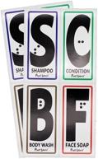 | Makes toileteries accessible for Blind visitors who use Braille | $13.00 (price in dollars on Amazon)
RNIB Tactile Maps | 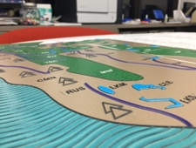 | Provides ‘tactile’ information about a venue for visitors who are blind or have sight loss | Varies dependent upon size and type required
Audio Bench | 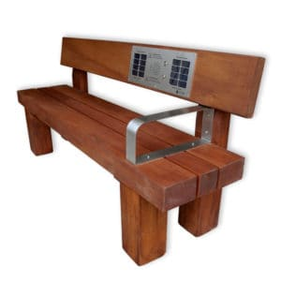 | Plays audio information describing the history of a place, a view etc. to assist visitors who are Blind or partially sighted. | £1,995 to £2, 145 exc VAT for model shown

Items to assist autistic visitors

Item | Image | Description / Purpose | Price
Ear Defenders | 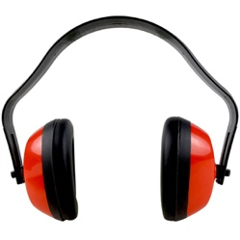 | Reduces noise levels for visitors with sensory sensitivity e.g. autistic visitors | £1.98 inc VAT

Items to assist autistic visitors or visitors with learning disabilities

Item | Image | Description / Purpose | Price
Sensory Equipment Packages | 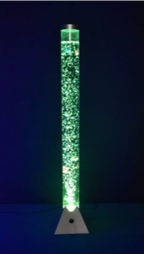 | Help to create a calming environment for visitors e.g. visitors with learning disabilities or autistic visitors | Prices range from £40 to £700 dependent on equipment required
Projector | 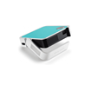 | As above | £138.54 inc VAT

Items to assist visitors living with dementia

Item | Image | Description / Purpose | Price
Neutral Threshold Mats | 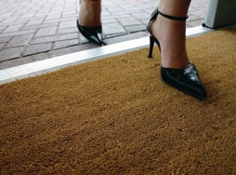 | Removes the barrier which dark mats can create for some visitors with dementia | £48.00 inc VAT
Memory Box | 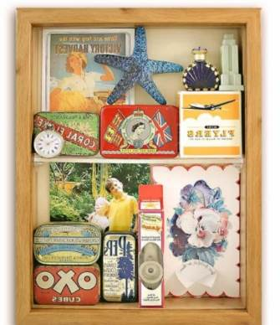 | Contain nostalgic items which can act as a memory- jogger and conversation – starter for visitors with dementia | 47.94 inc VAT

Items to assist wheelchair users or visitors with mobility impairments

Item | Image | Description / Purpose | Price
Pull down / adjustable wardrobe rail | 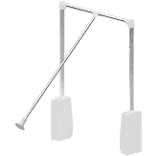 | Enabled a wheelchair user to access the clothes rail within a wardrobe | £39.41 inc VAT
Bed Blocks | 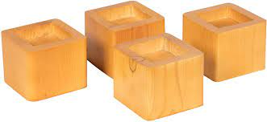 | Used to raise the level of a bed to enable easier access and to enable the base of a mobile hoist to slide underneath | From £24.50 for a set of four
Plastic wheelchair friendly matting | 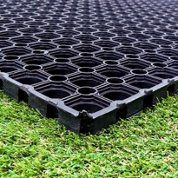 | Used to create a solid, wheelchair accessible surface over grassed or rough terrain | £21.37 inc vat for 1metre x 1.5 metre section
Portable ramps | 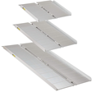 | A portable solution to creating level access where there is currently a step | Varies dependent upon size. Amazon prices are given below for illustration:  61cm - £39.99  91.5cm - £59.99  152.4cm - £89.99  Ramps, including bespoke ramps, are also availab from The Ramp People
Threshold ramps | 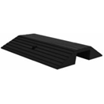 | Used to bridge a raised doorway threshold to create level access | £29.99
Trampers | 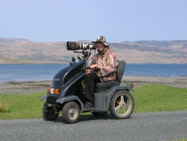 | Trampers vary in their robustness and range. This Beamer Krystal Tramper is designed to cope with rough terrain | £9,036 for Krystal Low Range Tramper
Adapted cycles | 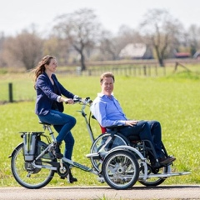 | Adapted cycles come in a range of styles, such as the one illustrated which can transport a wheelchair user on the front. | £5,475 for the model shown
Beach Wheelchair | 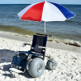 | Enables wheelchair users and people with mobility impairment to access the beach | £3564.00 inc VAT
Accessible picnic tables | 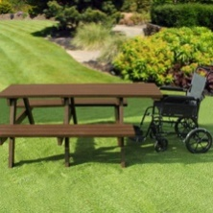 | Enables wheelchair users to pull right up to a picnic table | Price vary according to size and style. The product shown starts from £510 inc VAT
Electric profling bed | 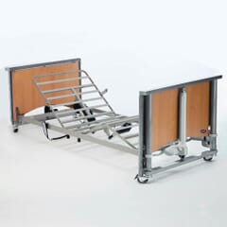 | Enabled a visitors with mobility impairment to adjust the position of the bed to suit their needs | £541.65 (VAT exempt)
Manual  Wheelchairs | 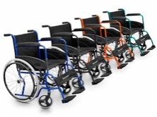 | Providing a wheelchair for visitors to borrow enables visitors with mobility impairment or who have fatigue to get around a venue | Prices are from £320 from Clark and Partners
All-Terrain Wheelchairs | 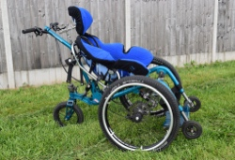 | All-Terrain wheelchairs enable visitors to navigate rough terrain and come in iether self-propelled or pushed models | £3595 for a Mountain Trike Push
Kingcraft Space To Change Kit: mobile hoist, privacy screen and changing table | 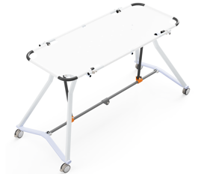 | Enables visitors who require changing when out and about to achieve this with dignity where no Changing Places toilet is provided nearby | £7674.96 inc VAT
Riser Recliner Chair | 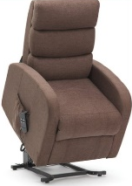 | Enable visitors with mobility impairment to lower themselves into and out of a seated position with ease. Also ideal to enable wheelchair users to relax and have a break from their wheelchair. | Prices start from around £411.84 plus VAT
Toilet Seat Raiser | 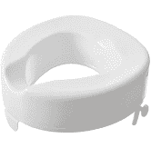 | Raises the height of a toilet seat to a more accessible position for visitors with mobility impairmient | £20.00 for model shown
Walking sticks | 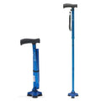 | Provides additional support for visitors whilst at your venue. | £17.99 for model shown.
Tabletop Walking stick holder | 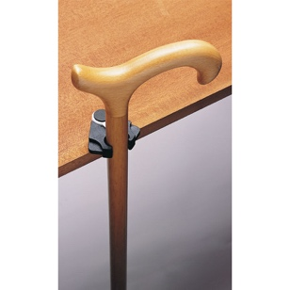 | Reduces the need to place a walking stick or cane on the ground. It secures onto the edge of a table, enabling the user to clip the stick into place to balance it against the table edge. Designed to fit firmly and securely, it attaches via foam pads located on the end of the stick holder. | £5.99 for model shown

Items which improve general accessibility

Item | Image | Description / Purpose | Price
Large handled cutlery | 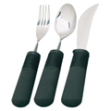 | Helpful for visitors who may find it difficult to hold regular cutlery | £32.99 per set including VAT
Beakers | 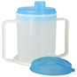 | Helpful for visitors who may find it difficult to use a regular cup or glass | £4.98 including VAT
Accessible Play Equipment | 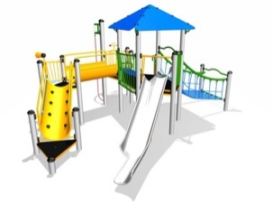 | Helps to create an inclusive environment in play areas and inclused things such as wheelchair accessibel swings & level access tramolines etc. | Varies dependent upon equipment needed
Improved signage and interpretation | 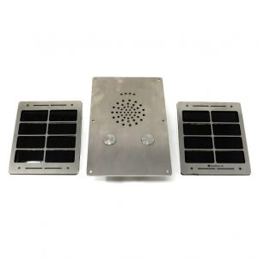 | Provide interpretation in formats which are accessible for visitors with different access requirements | Solar audio post shown is from £599 to £767 exc VAT
Lockable Medecine Fridge | 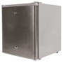 | Enables medecines to be safely locked away | £222.85
Garden Water Feature | 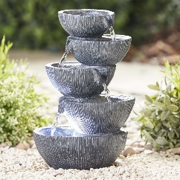 | Helps to creats a soothing, sensory garden environment | £34.99
Creation of new website |  | New, accessible website showcasing inclusive information, facilities and services | Prices vary dependent on functionality etc. but an average cost for a small business is in the region of £500 - £1000

